Created user name in git and added

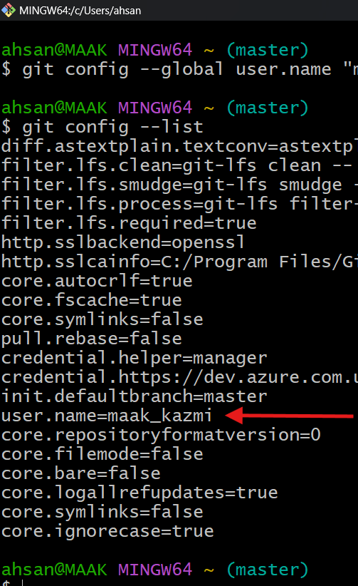

Added to repository track , $git log

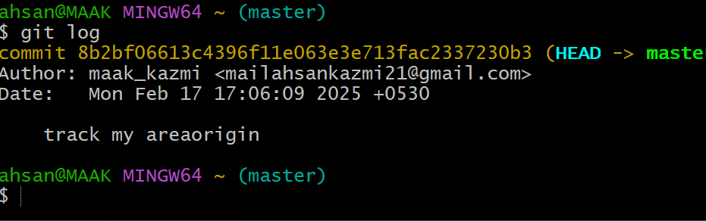

Using command

Git remote –v

Git push –v originmaster

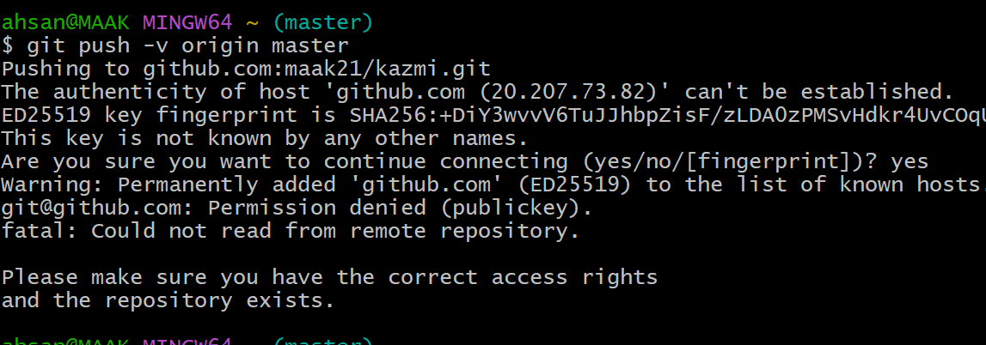

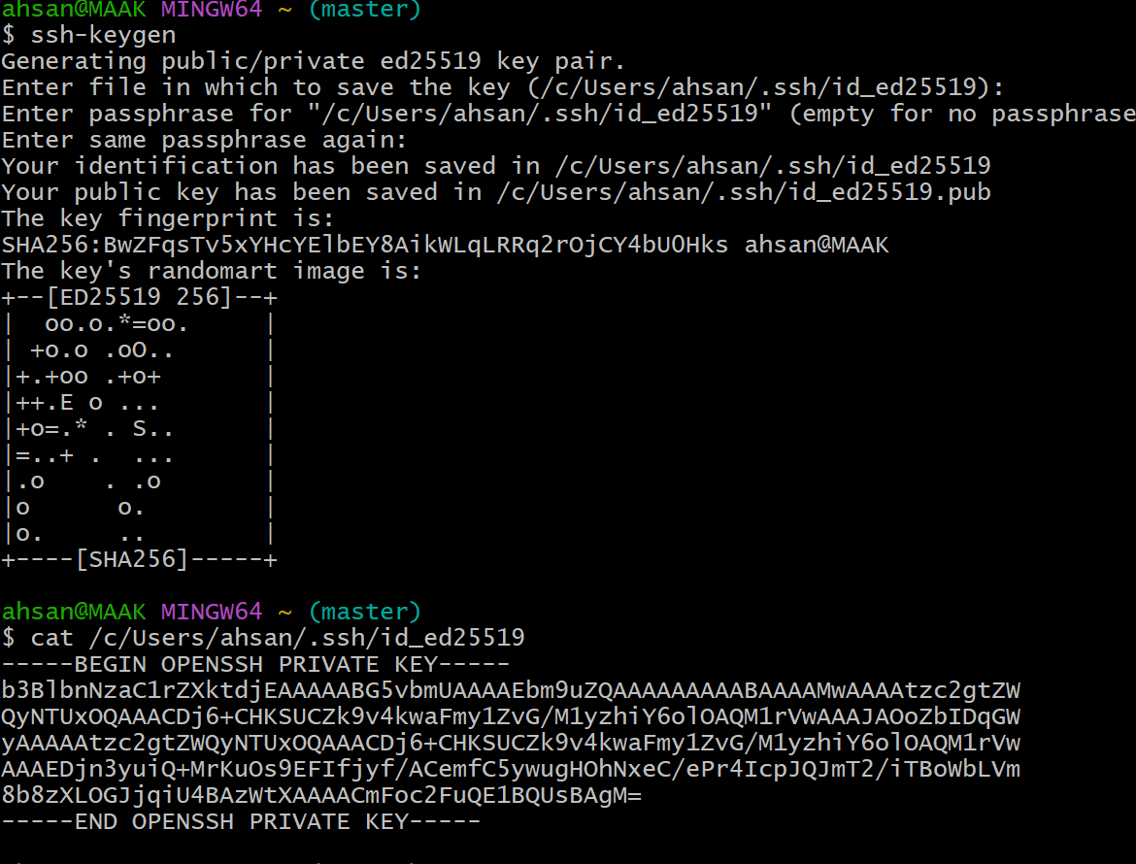

Another option if ssh key not correct generate

$cd ~/.ssh

$ll

File name id-ed25519.pub

Cat filename

You will get key

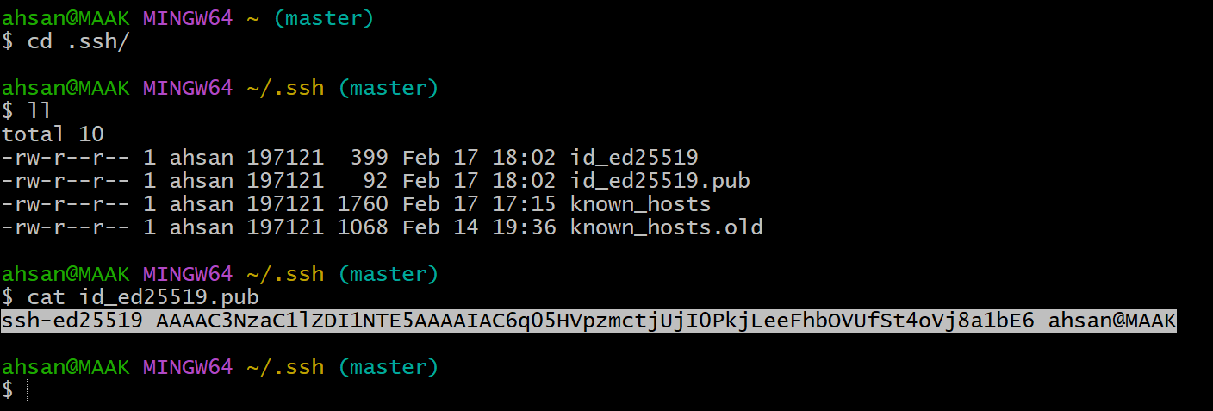

After $get push –u origin master

This page will occer

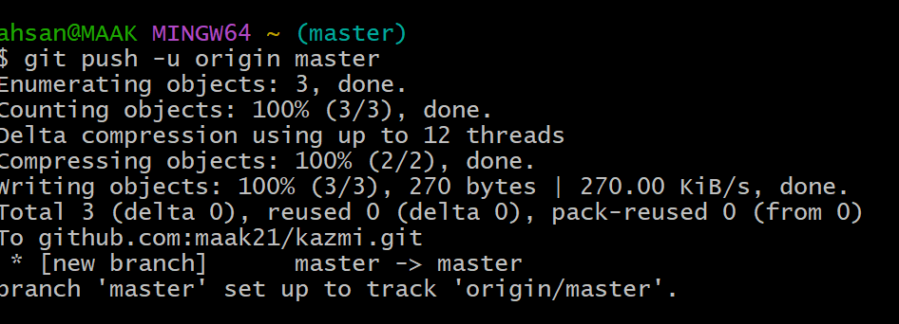

Now data got transferred centeral repository

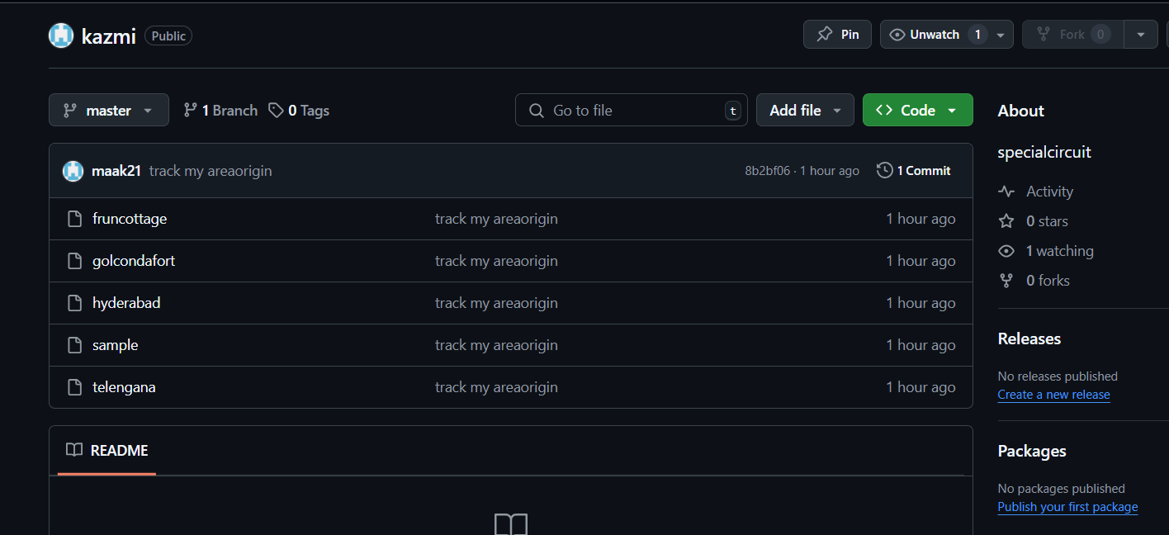

I HAVE MOVE THE REPOSITORY FROM ONE REPOSITORY TO ANOTHER REPOSITROY USING COMMED CHEERY PIC

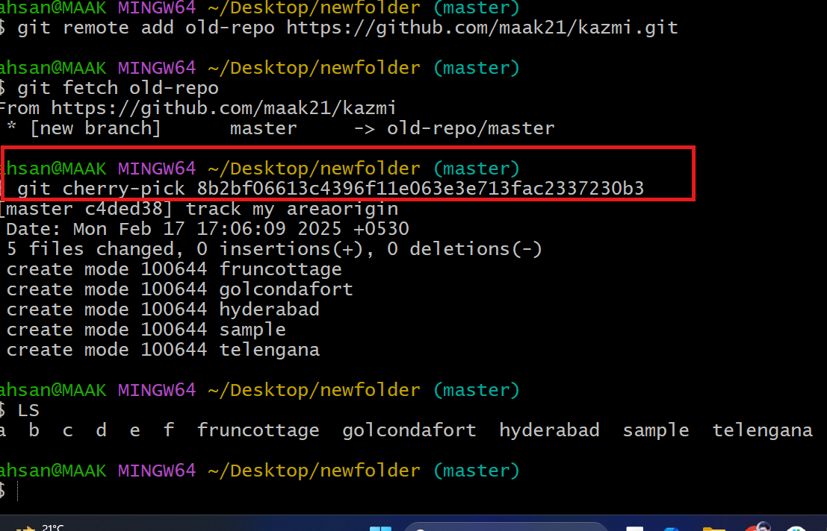

your local branch and the remote origin/master branch have diverged, which means there are different commits on each branch. Here’s how you can synchronize them:

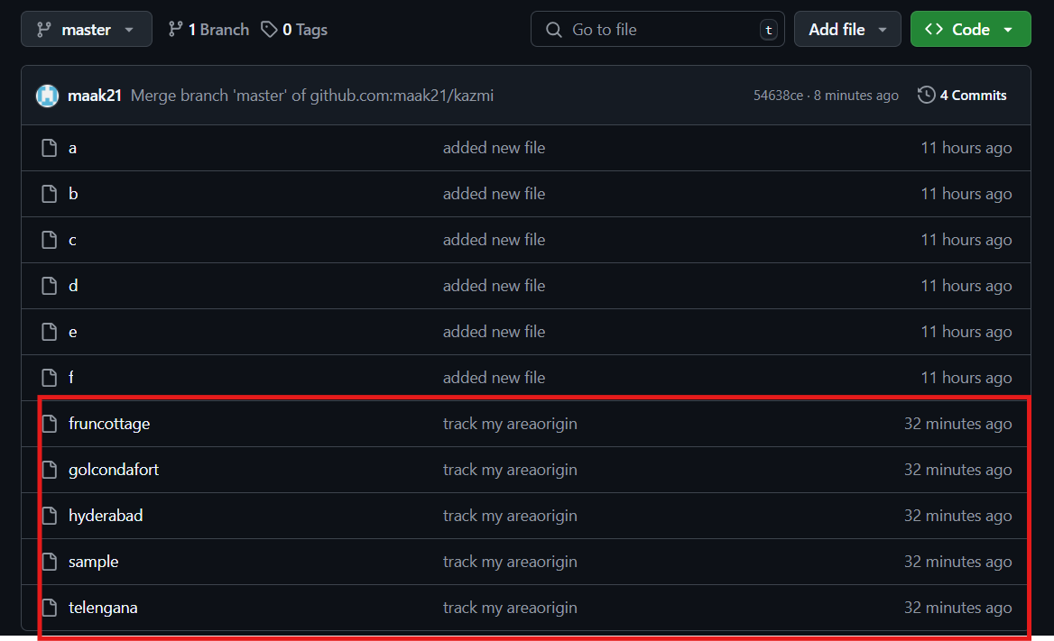

Done with the cloning command

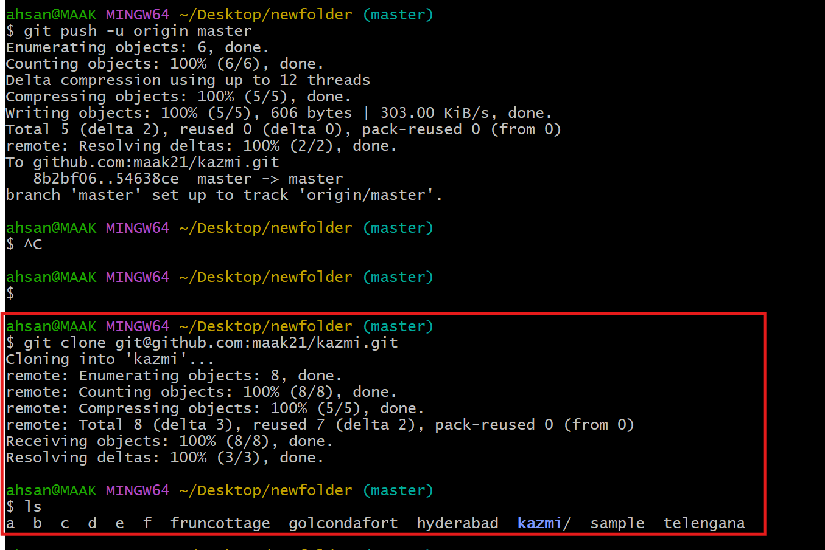

Using pull command to get sychrojm from centeral repository to local machine

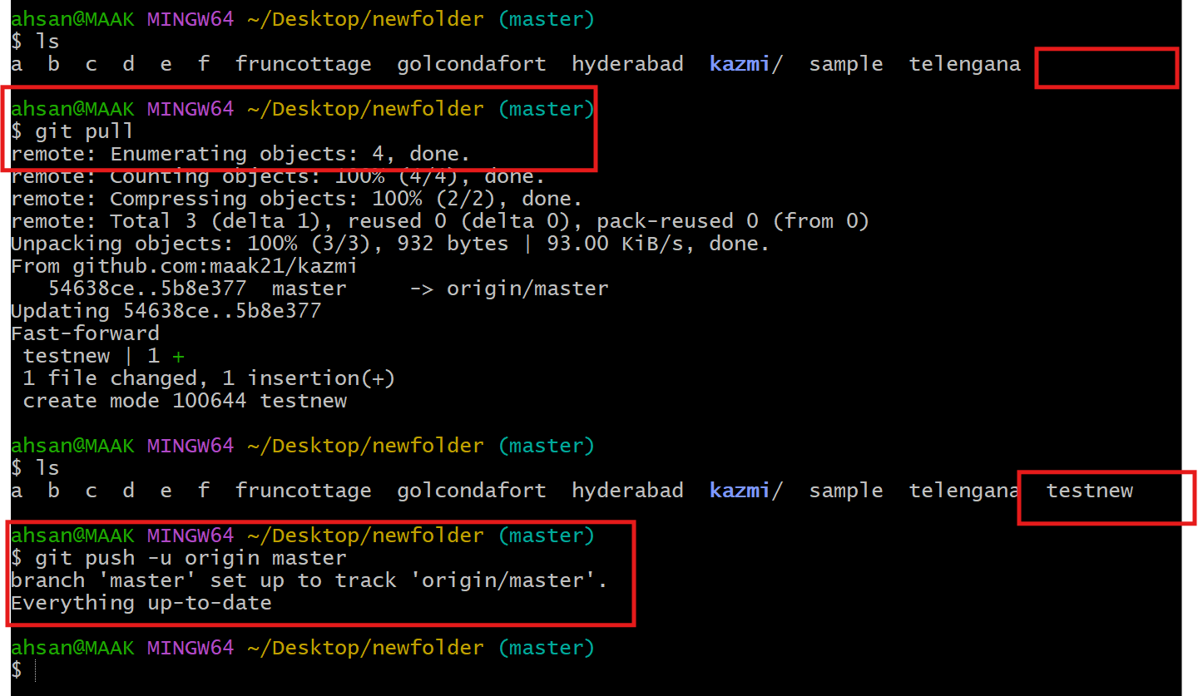

Git log it shows merge the master 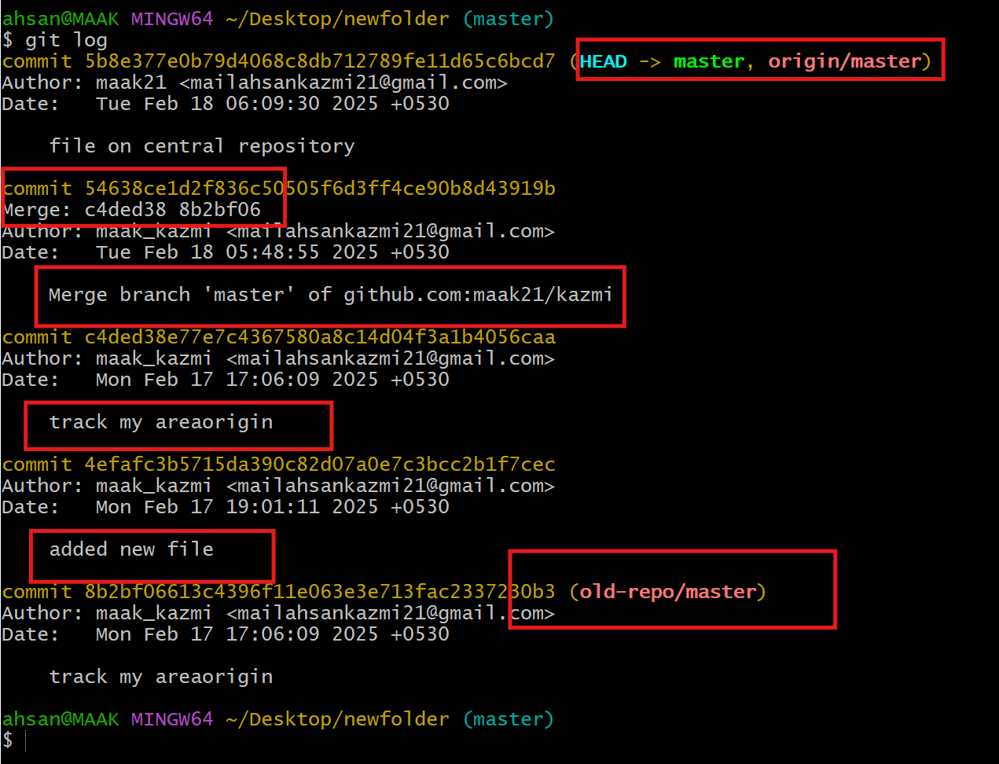

Git remote –v

It shows the all removte repository including old repo including fetch

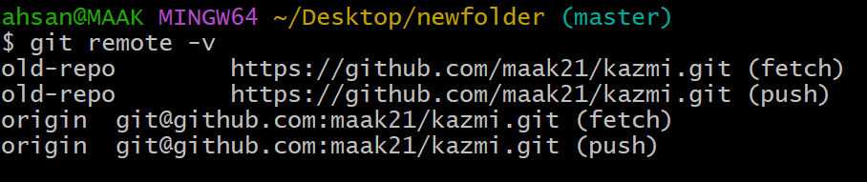

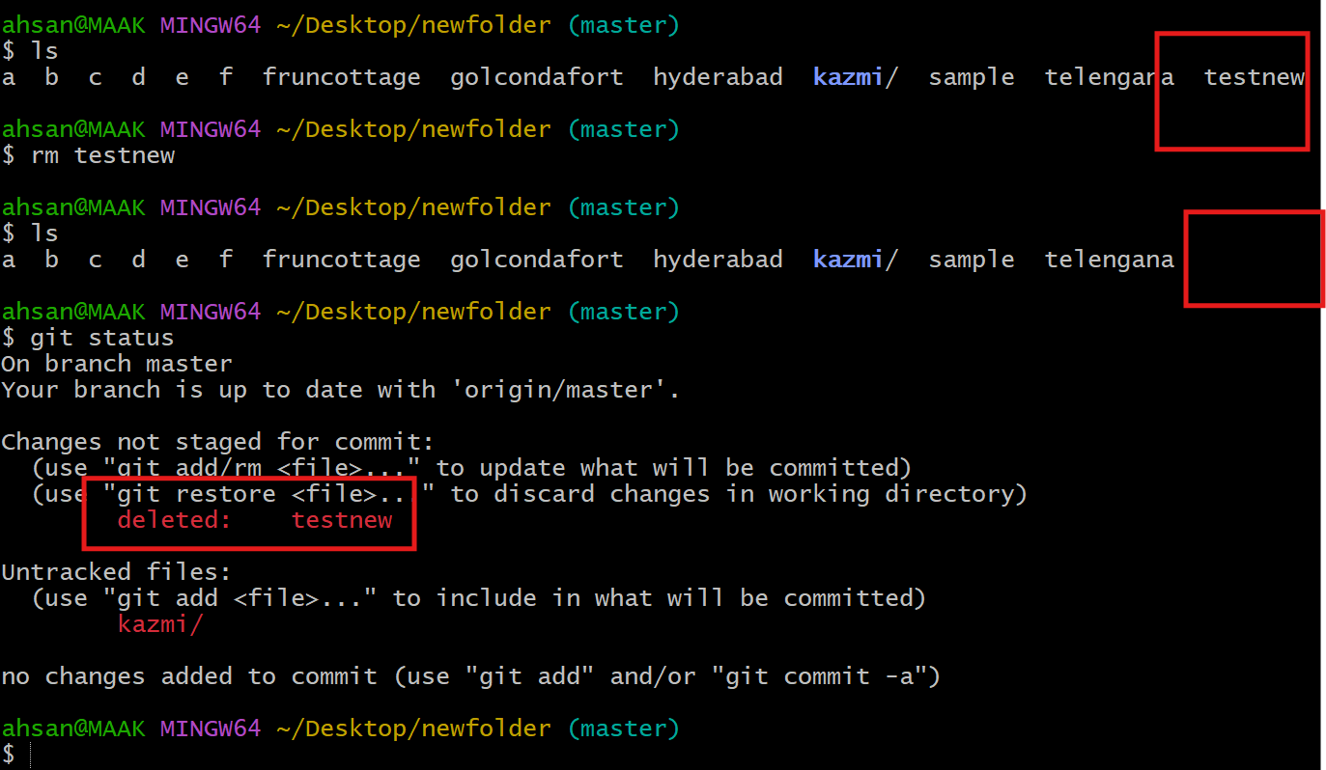

Delted file testnew by using comments

rm testnew

git add .

git commit -m "deleted testnew"

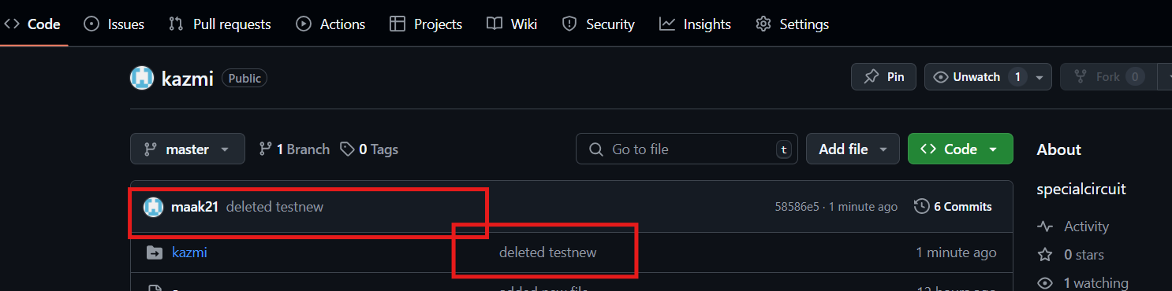

To get back deleted file

Go to

Git log ( it shows all the log files)

Git log -4 (it shows all 4 lines of log

git revert 58586e

